**WORDPRESS INSTALLATION PROCEDURE**

To install wordpress we need to first install web server softwares like XAMPP,WAMPP.

XAMPP INSTALLATION

Go to website https://www.apachefriends.org/download.html

We can see different versions of XAMPP. Click on the lastest version and start downloading.

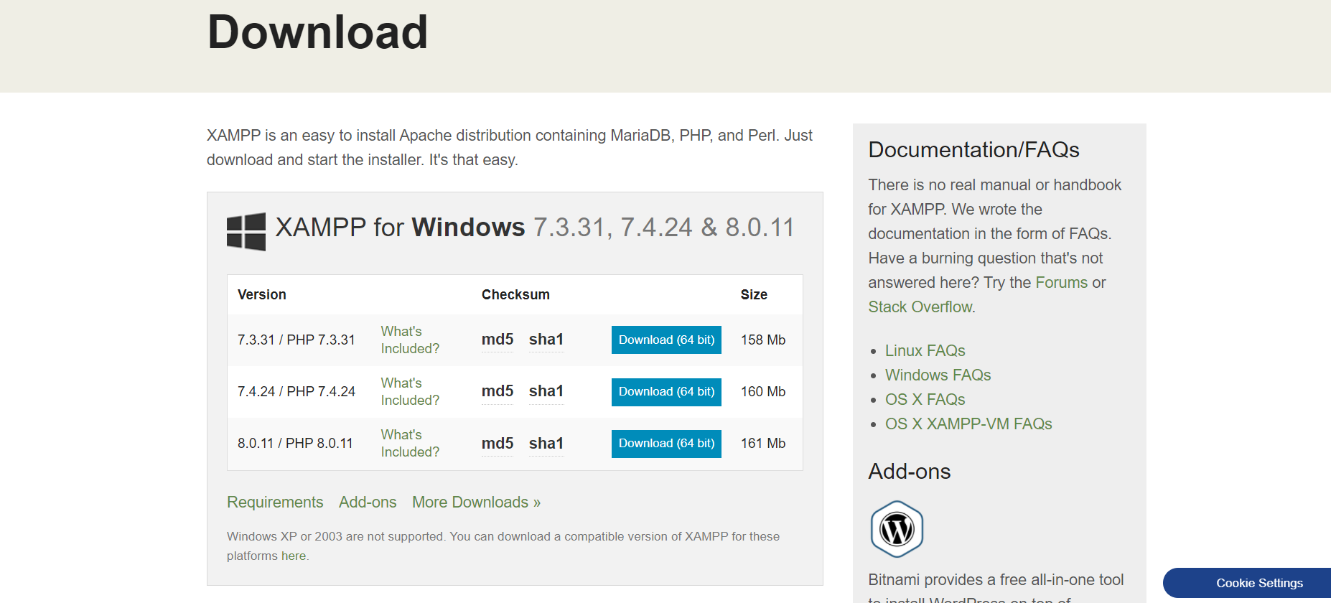

After downloading install XAMPP by simply clicking on next button.

Once XAMPP is installed we can see the below control panel.

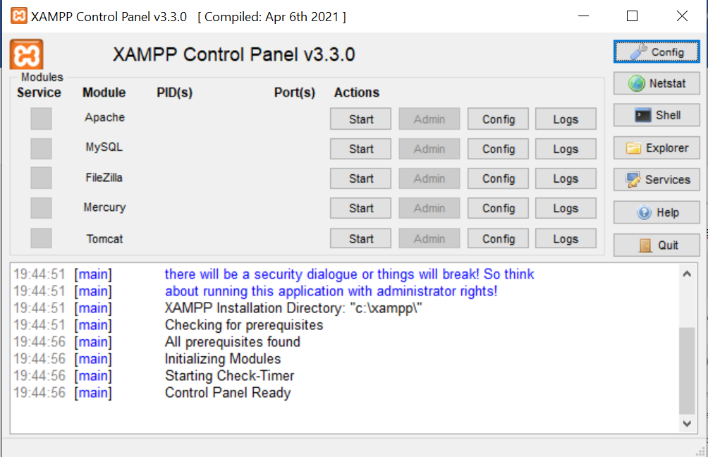

Start Apache and MySQL.

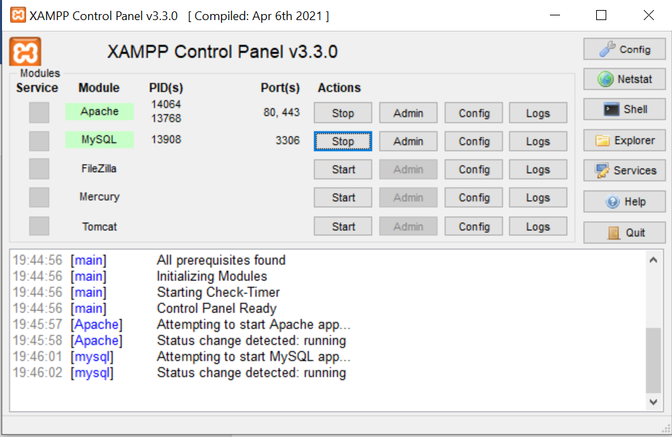

On web browser type localhost/. If we can see the below web page we can ensure that our server is running properly.

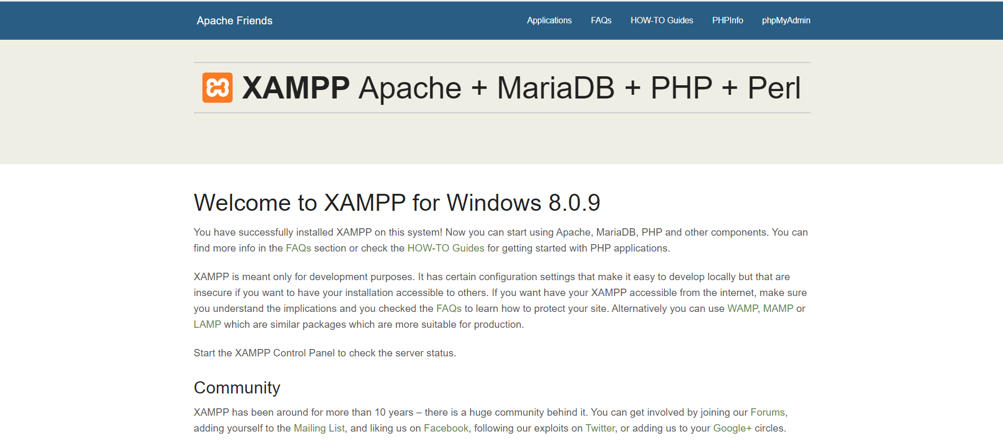

We also need database to develop dynamic websites using wordpress. So we need to create a database. To create database go to phpMyAdmin on local host.

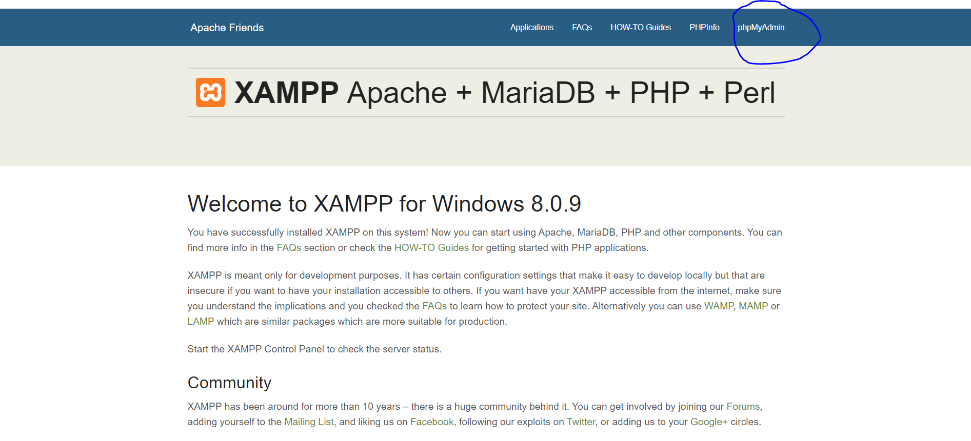

Click on new and give name to the database.

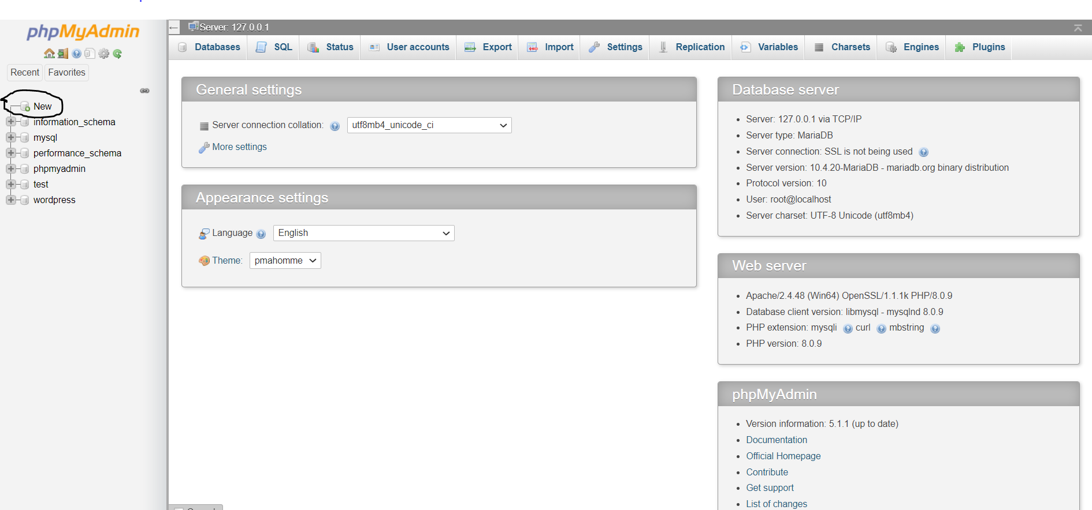

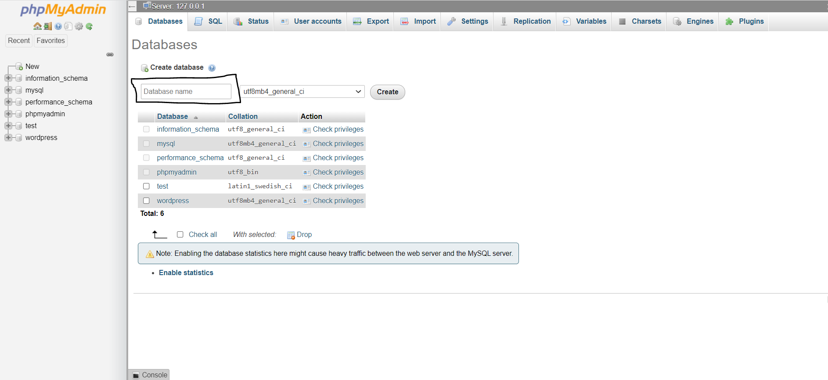

We are done with installation of XAMPP and creation of database.

WORDPRESS INSTALLATION

Now we need to download and install word press.

Go to <https://wordpress.org/download/>

Click on download.

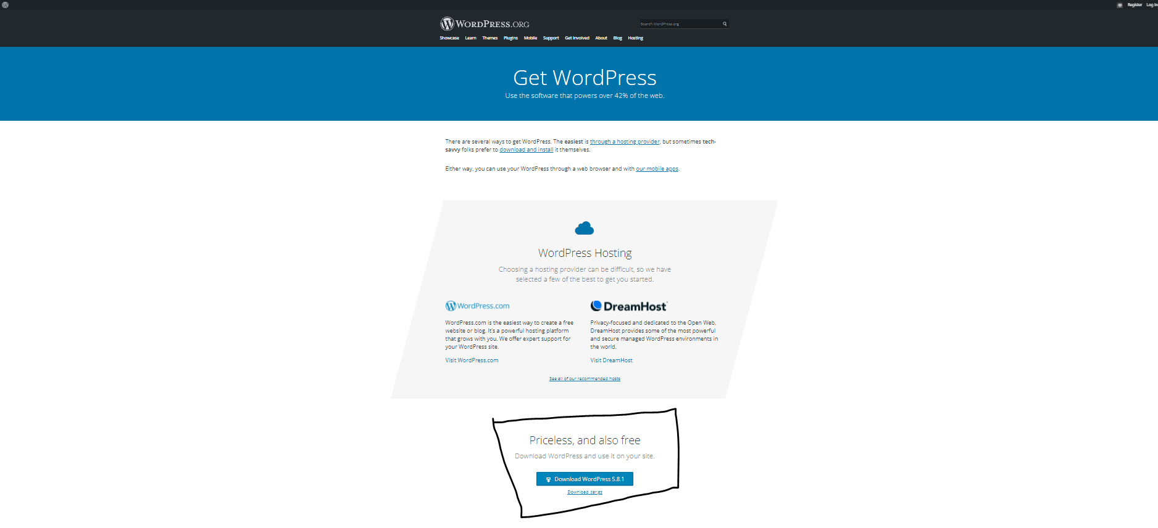

A zip file gets downloaded. Extract the file and place the folder in htdocs of XAMPP.Name the folder.

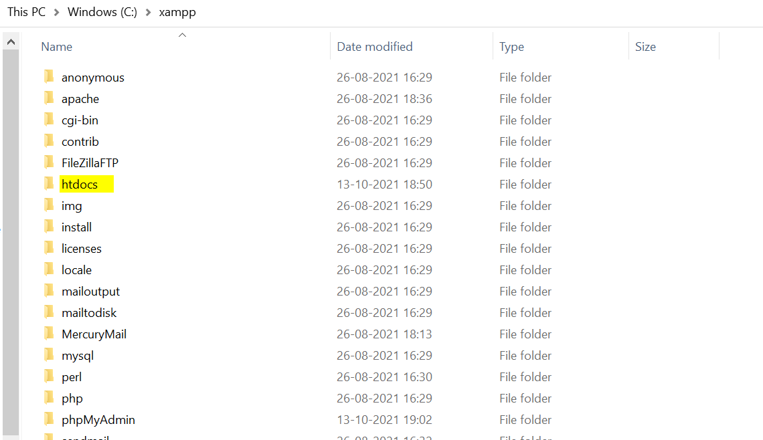

On web browser type localhost/(folder_name) to install wordpress.

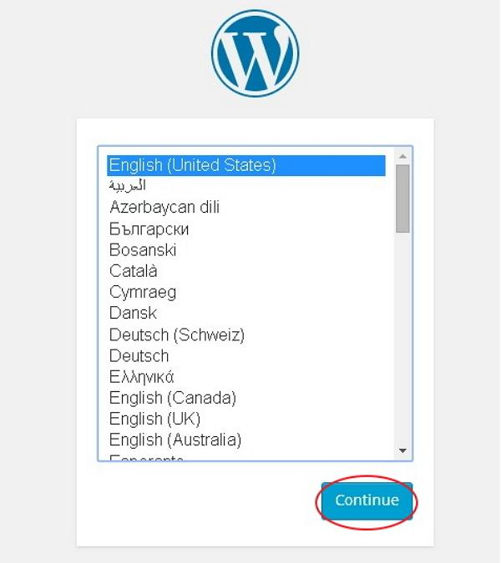

Select language and click on continue.

After that we can see below web page. As we already created database and have all the required information of database click on let’s go.

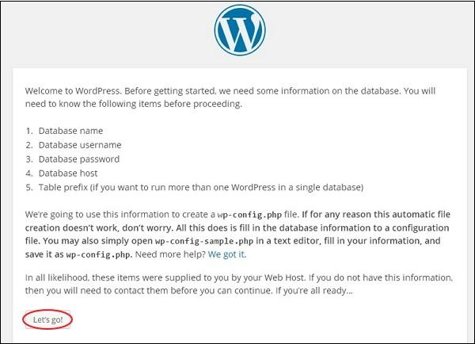

Enter information of database and click on submit.

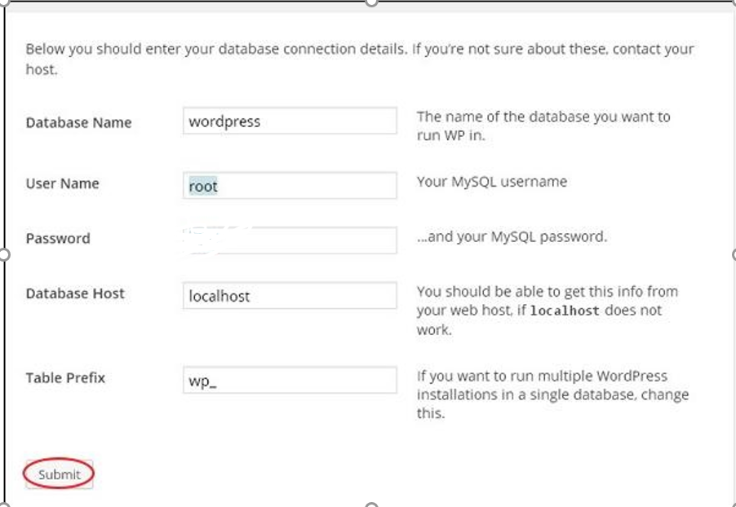

Database name is the name that we entered while creating database.

Wordpress checks the database setting and gives the confirmation screen.

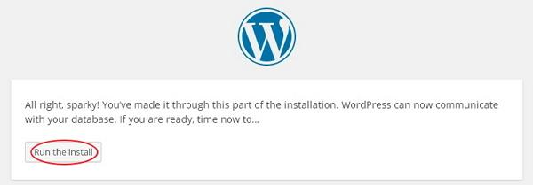

 Enter administrative information.

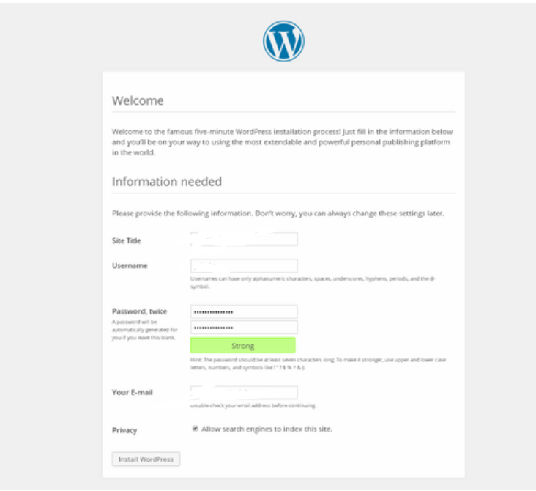

After filling information click on Install WordPress button.

After successful installation we will get the below screen.

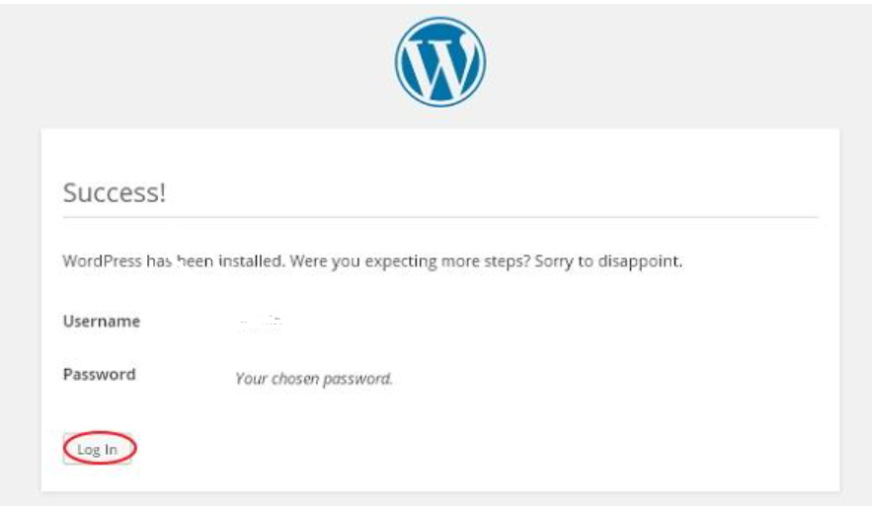

Click on log in.

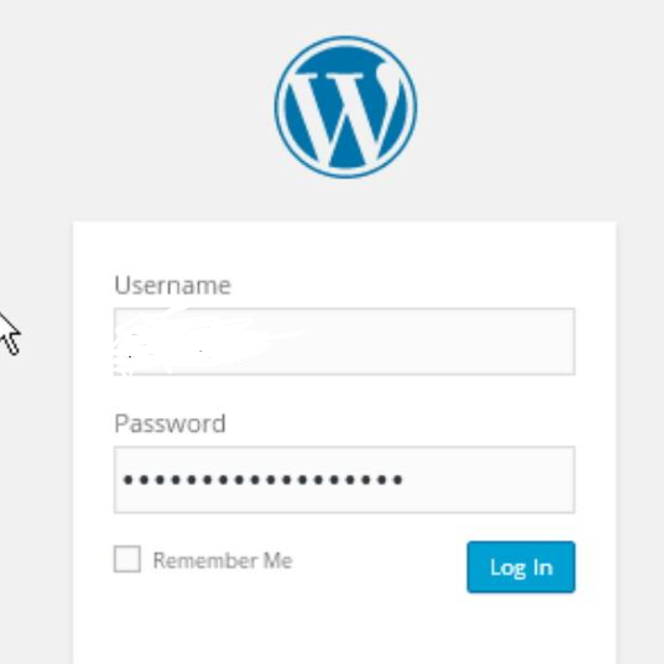

After logging in we can see the below screen.

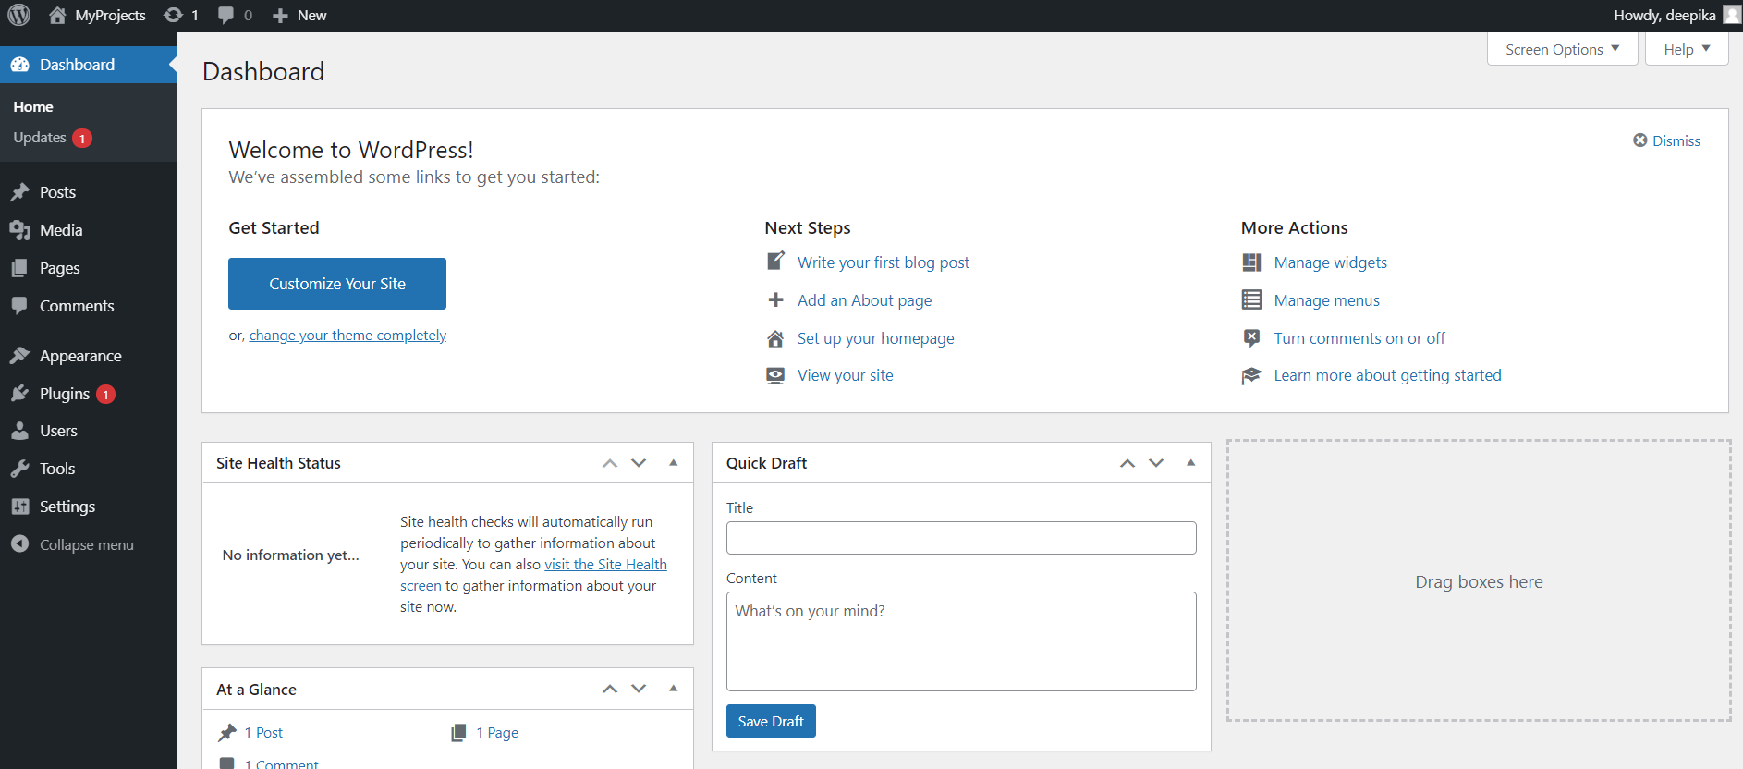

We installed word press successfully and we can start with our website development. By default our website is as shown in the following picture.

